Najaf Riaz
F2024065431
W-2

Student Attendance System

1. Project Overview

The Student Attendance System is a digital method to record and manage student attendance. It helps teachers mark attendance easily, students check their attendance, and admins manage all records smoothly.

2. Functional Requirements

Teacher Panel
1. Login / Logout
2. Select class
3. Mark attendance (Present/Absent/Late)
4. Edit attendance
5. View attendance summary

Student Panel

6. Student login
7. View personal attendance percentage
8. View monthly attendance report
Admin Panel
9. Add / Update / Delete students
10. Add / Manage teachers
11. Add classes & subjects
12. Generate attendance reports (daily/monthly)

3. Non-Functional Requirements

Performance:

Attendance should be marked in less than 2 seconds
Should handle 100+ users
Usability
Simple, responsive, mobile-friendly interface
Security
Password hashing
Role-based access control
Availability
99% uptime
Backup system available
Reliability
Accurate attendance calculation
Data loss prevention
4. Use Case Diagram (Student Attendance System)
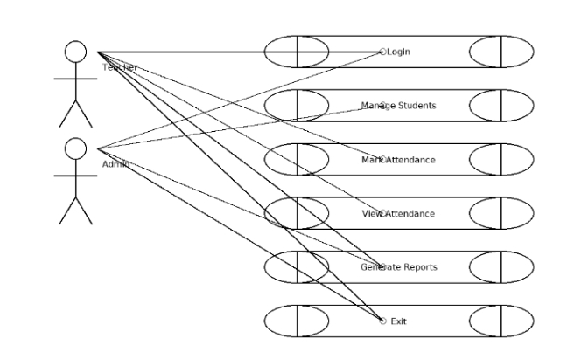

5. Use Case Details

Use Case: Mark Attendance

Actor: Teacher
Pre-condition: Teacher logged in
Main Flow:
1. Teacher selects class
2. System shows student list
3. Teacher marks Present/Absent
4. System saves data
Post-condition: Attendance saved
Use Case: View Attendance (Student)

Actor: Student
Main Flow:
1. Student opens attendance
2. System shows percentage
3. Student downloads details
Post-condition: Attendance shown

Use Case: Manage Students

Actor: Admin
Main Flow:
1. Admin adds/updates/deletes student
2. System updates database

6. Association (Who Does What)
Actor Role

Admin Manages students, teachers, subjects & reports
Teacher Marks and edits attendance
Student Views own attendance

Prototype Screen
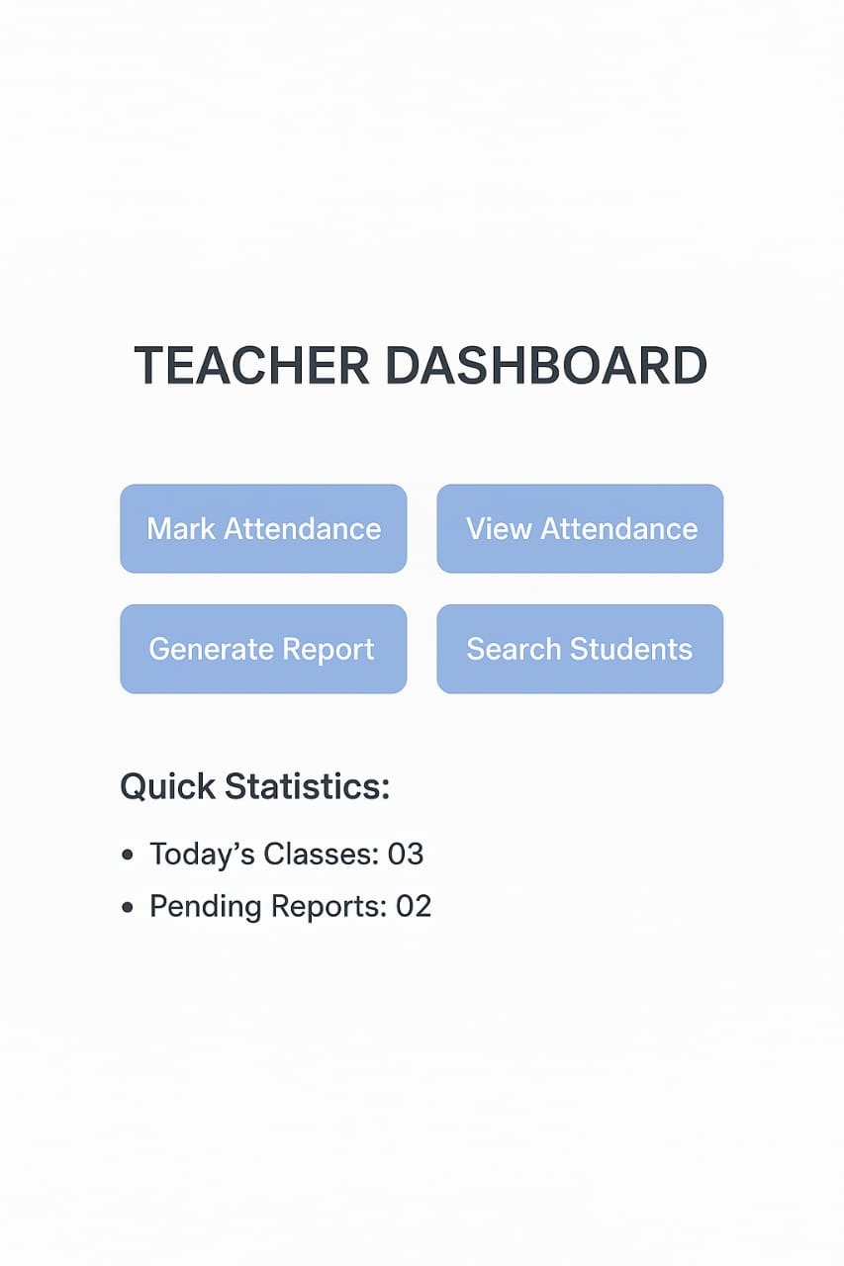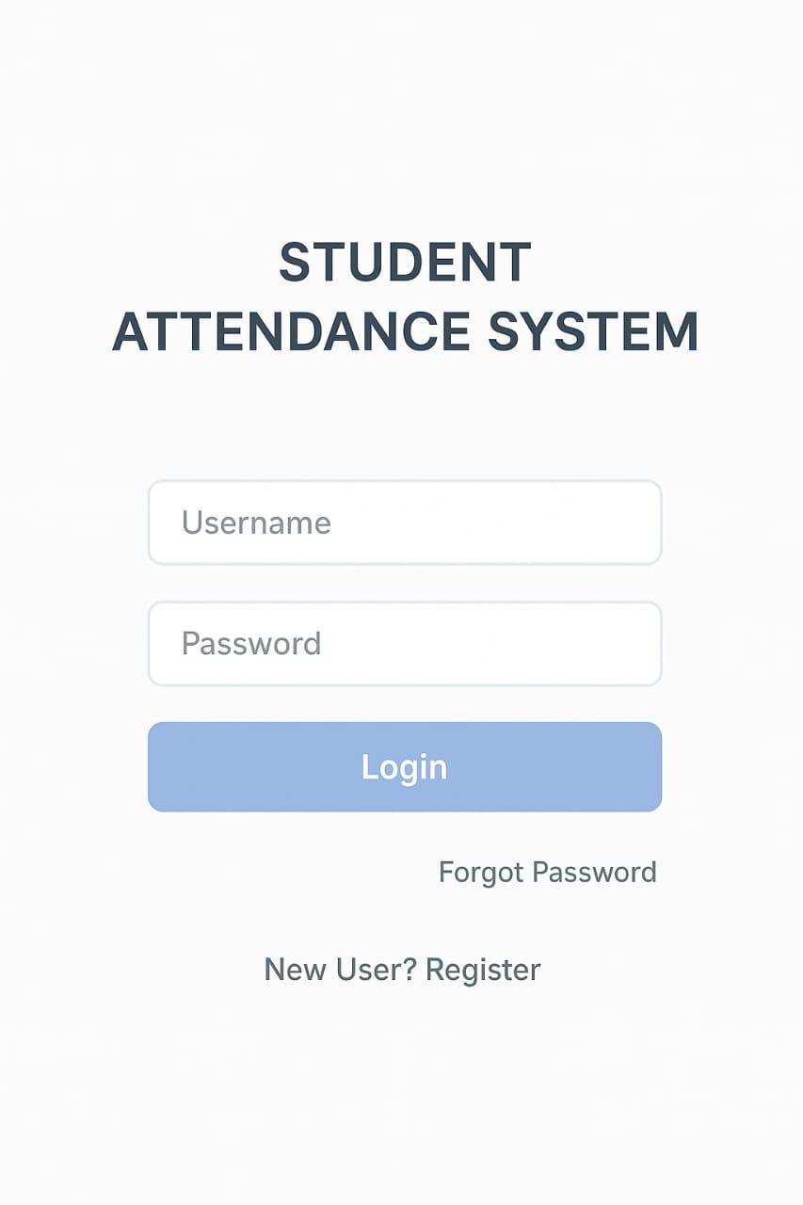
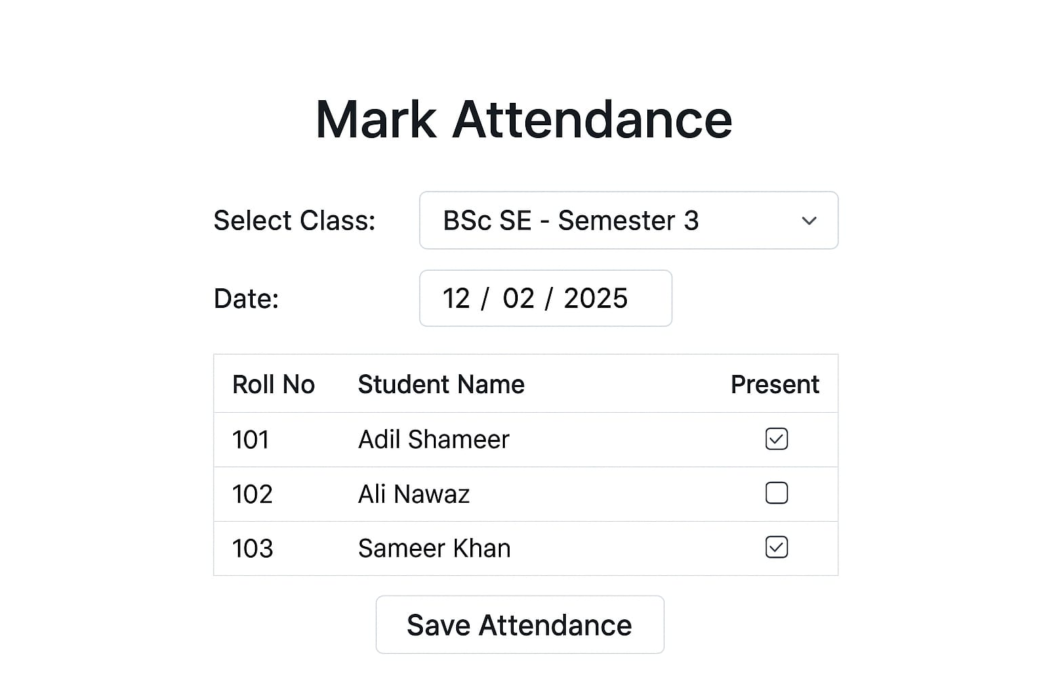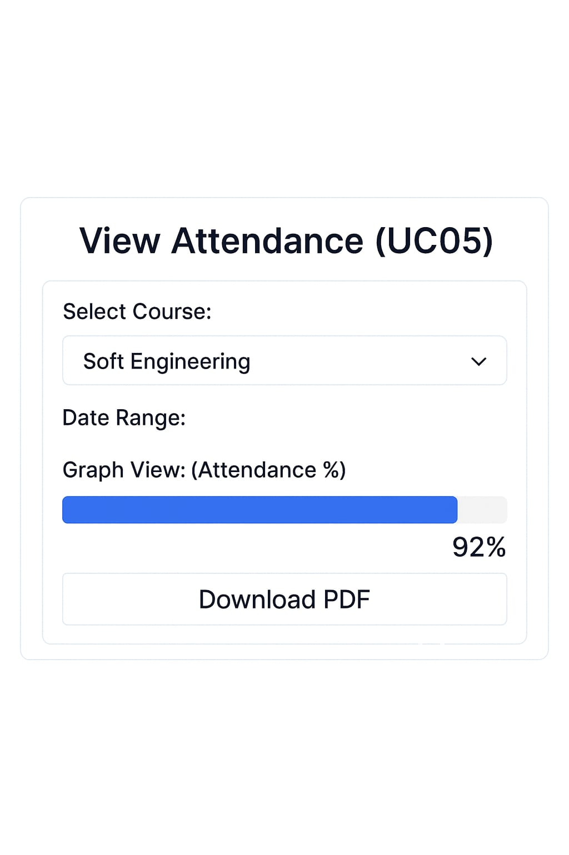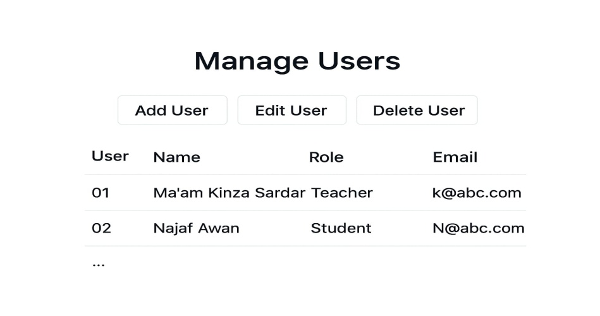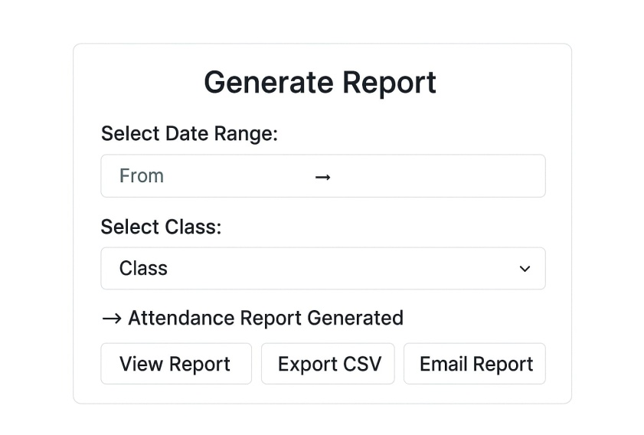
7. Conclusion

This system makes attendance fast, easy, and accurate. Teachers save time, students get clear information , and admins can manage everything without difficulty.

